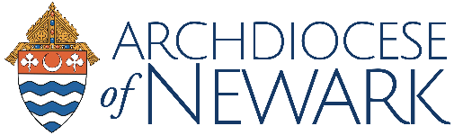

FOR INTERNAL USE ONLY – NOT TO BE DISTRIBUTED

ADDENDUM III
Directives for Re-Opening Churches
(Issued June 19, 2020)

As has already been announced, Phase Three of the Directives for Re-Opening Churches commences on

Sunday, June 21, 2020

This is the Twelfth Sunday in Ordinary Time and includes the Vigil Mass on Saturday, June 20, 2020.

Phase Three continues the dispensation from the Sunday obligation and Easter Duty, all celebrations permitted in Phase Two and extends the celebration of public Mass to Sundays with all directives in force.

All prior issuances regarding the Directives for Re-Opening Churches remain in force with the following addition:

The number of participants for all liturgies remains at 25% of the church’s capacity or 50 participants in total, whichever number is lower.

There was some confusion about the numbers and for this we apologize. However, the number above, which in most cases will be 50, is in force until further notice.

